Task 5: External Tables on the Staging Layer

Global Retail Superstore Sales - Tamar Tutisani

Question: Why is the Staging Area Necessary, and Why Can't We Load Directly into the 3NF Layer?

Purpose of the Staging Area
The staging area (SA layer) is the first landing zone for raw data extracted from operational source systems. Its role is to hold data exactly as it arrives from the source with no transformations, no business rules applied, and no integration with other sources. In this project, two schemas are created:
- SA_DOMESTIC - holds raw data from the Domestic Sales system (United States and Canada)
- SA_INTERNATIONAL - holds raw data from the International Sales system (APAC, EU, EMEA, LATAM, Africa)
The staging layer serves the following purposes:
- Decoupling extraction from transformation. By separating the "get the data in" step from the "clean and integrate" step, the ETL pipeline becomes modular. If a transformation fails, the raw data is already safely landed and the transformation can be re-run without re-extracting from the source.
- Preserving a raw copy of source data. The staging area acts as an audit trail. If a business rule is later found to be wrong, we can re-derive the 3NF layer from the untouched raw data rather than re-extracting from the source system.
- Enabling change data capture and incremental loading. The staging area makes it possible to compare today's raw data against yesterday's and identify only the new or changed rows before touching the 3NF layer.
- Supporting deduplication. Raw source data frequently contains duplicates (repeated rows with the same order line appearing more than once due to re-exports or system quirks). Deduplication is performed at the staging layer, specifically when populating the SRC_ tables from the EXT_ tables, so that only clean, deduplicated rows flow into BL_3NF.
- Isolating source-system differences. The two source systems in this project have structural differences (e.g. Domestic has Ship Mode and Order Priority; International has State but no Ship Mode). The staging area preserves these differences faithfully; the integration and reconciliation of these differences happens in BL_3NF.

Why We Cannot Load Directly into the 3NF Layer
Loading raw source data directly into the 3NF layer is not possible for the following reasons:
- Raw data is not clean. Source CSVs may contain duplicate rows, null values, inconsistent formatting, and mismatched identifiers. The 3NF layer enforces NOT NULL constraints, referential integrity via foreign keys, and sequence-generated surrogate keys, none of which can be satisfied by unprocessed raw data.
- Integration requires a staging point. The 3NF layer integrates both source systems into shared CE_ tables (e.g. one CE_PRODUCTS table for both Domestic and International products). This integration requires comparing incoming rows against what already exists in the target, which requires a stable intermediate landing zone, the staging area.
- Surrogate key generation requires a controlled pipeline. The 3NF layer uses sequences to generate surrogate keys. These keys can only be assigned correctly after deduplication and lookups have been performed in the staging area. Skipping staging would mean attempting to assign surrogates to raw, unvalidated, potentially duplicate rows.
- SCD logic requires a comparison point. CE_CUSTOMERS_SCD uses SCD Type 2. To detect whether a customer's segment has changed, the ETL process must compare the incoming staged row against the current active row in CE_CUSTOMERS_SCD. This comparison requires the raw row to be landed and validated in staging first.
- Error isolation. If a bad batch of data is loaded directly into 3NF and causes constraint violations or bad joins, recovery is extremely difficult. With a staging area, the bad data is isolated and can be corrected before it ever reaches the integrated layer.

Objects Created

Two Schemas (one per source system):
Schema | Source System
SA_DOMESTIC | Domestic Sales (US + Canada)
SA_INTERNATIONAL | International Sales (APAC, EU, EMEA, LATAM, Africa)

External Tables (EXT_) - file_fdw foreign tables pointing directly to CSV files:
Table | Schema | File
EXT_DOMESTIC_SALES | SA_DOMESTIC | SRC_DOMESTIC_SALES.csv
EXT_INTERNATIONAL_SALES | SA_INTERNATIONAL | SRC_INTERNATIONAL_SALES.csv

Source Tables (SRC_) — regular PostgreSQL tables, deduplicated copy of raw data:
Table | Schema | Populated From
SRC_DOMESTIC_SALES | SA_DOMESTIC | EXT_DOMESTIC_SALES (deduplicated)
SRC_INTERNATIONAL_SALES | SA_INTERNATIONAL | EXT_INTERNATIONAL_SALES (deduplicated)

Deduplication Logic
Deduplication is applied when loading from EXT_ into SRC_ tables. A row is considered a duplicate if all business key columns are identical:
- Domestic: order_id + product_id + customer_id + order_date
- International: order_id + product_id + customer_id + order_date
ROW_NUMBER() OVER (PARTITION BY <key columns> ORDER BY row_id) is used and only rn = 1 rows are inserted into the SRC_ tables.

Results
SELECT * FROM sa_domestic.ext_domestic_sales LIMIT 5;
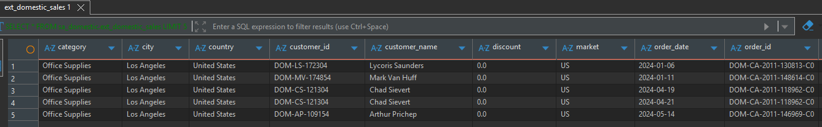

SELECT * FROM sa_domestic.src_domestic_sales LIMIT 5;
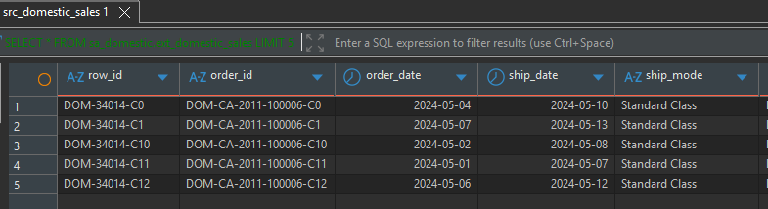
SELECT * FROM sa_international.ext_international_sales LIMIT 5;
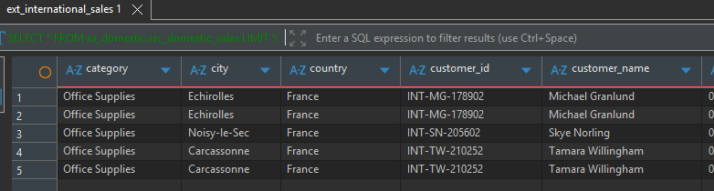

SELECT * FROM sa_international.src_international_sales LIMIT 5;
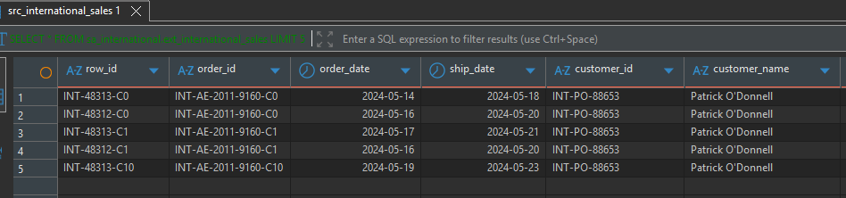

Deduplication Summary (lines 362-381 in Task5_Tamar_Tutisani.sql):
